library(tidyverse)

## ── Attaching core tidyverse packages ──────────────────────── tidyverse 2.0.0 ──  
## ✔ dplyr 1.1.2 ✔ readr 2.1.4  
## ✔ forcats 1.0.0 ✔ stringr 1.5.0  
## ✔ ggplot2 3.4.2 ✔ tibble 3.2.1  
## ✔ lubridate 1.9.2 ✔ tidyr 1.3.0  
## ✔ purrr 1.0.1   
## ── Conflicts ────────────────────────────────────────── tidyverse_conflicts() ──  
## ✖ dplyr::filter() masks stats::filter()  
## ✖ dplyr::lag() masks stats::lag()  
## ℹ Use the conflicted package (<http://conflicted.r-lib.org/>) to force all conflicts to become errors

library(ggplot2)  
library(RColorBrewer)  
library(gridExtra)

##   
## Attaching package: 'gridExtra'  
##   
## The following object is masked from 'package:dplyr':  
##   
## combine

Ames = read_csv("ames_student.csv")

## Rows: 2053 Columns: 81  
## ── Column specification ────────────────────────────────────────────────────────  
## Delimiter: ","  
## chr (47): MS_SubClass, MS_Zoning, Street, Alley, Lot_Shape, Land_Contour, Ut...  
## dbl (34): Lot_Frontage, Lot_Area, Year_Built, Year_Remod_Add, Mas_Vnr_Area, ...  
##   
## ℹ Use `spec()` to retrieve the full column specification for this data.  
## ℹ Specify the column types or set `show_col_types = FALSE` to quiet this message.

str(Ames)

## spc_tbl_ [2,053 × 81] (S3: spec_tbl_df/tbl_df/tbl/data.frame)  
## $ MS_SubClass : chr [1:2053] "One_Story_1946_and_Newer_All_Styles" "One_Story_1946_and_Newer_All_Styles" "One_Story_1946_and_Newer_All_Styles" "One_Story_1946_and_Newer_All_Styles" ...  
## $ MS_Zoning : chr [1:2053] "Residential_Low_Density" "Residential_High_Density" "Residential_Low_Density" "Residential_Low_Density" ...  
## $ Lot_Frontage : num [1:2053] 141 80 81 93 74 78 43 39 0 85 ...  
## $ Lot_Area : num [1:2053] 31770 11622 14267 11160 13830 ...  
## $ Street : chr [1:2053] "Pave" "Pave" "Pave" "Pave" ...  
## $ Alley : chr [1:2053] "No_Alley_Access" "No_Alley_Access" "No_Alley_Access" "No_Alley_Access" ...  
## $ Lot_Shape : chr [1:2053] "Slightly_Irregular" "Regular" "Slightly_Irregular" "Regular" ...  
## $ Land_Contour : chr [1:2053] "Lvl" "Lvl" "Lvl" "Lvl" ...  
## $ Utilities : chr [1:2053] "AllPub" "AllPub" "AllPub" "AllPub" ...  
## $ Lot_Config : chr [1:2053] "Corner" "Inside" "Corner" "Corner" ...  
## $ Land_Slope : chr [1:2053] "Gtl" "Gtl" "Gtl" "Gtl" ...  
## $ Neighborhood : chr [1:2053] "North_Ames" "North_Ames" "North_Ames" "North_Ames" ...  
## $ Condition_1 : chr [1:2053] "Norm" "Feedr" "Norm" "Norm" ...  
## $ Condition_2 : chr [1:2053] "Norm" "Norm" "Norm" "Norm" ...  
## $ Bldg_Type : chr [1:2053] "OneFam" "OneFam" "OneFam" "OneFam" ...  
## $ House_Style : chr [1:2053] "One_Story" "One_Story" "One_Story" "One_Story" ...  
## $ Overall_Qual : chr [1:2053] "Above_Average" "Average" "Above_Average" "Good" ...  
## $ Overall_Cond : chr [1:2053] "Average" "Above_Average" "Above_Average" "Average" ...  
## $ Year_Built : num [1:2053] 1960 1961 1958 1968 1997 ...  
## $ Year_Remod_Add : num [1:2053] 1960 1961 1958 1968 1998 ...  
## $ Roof_Style : chr [1:2053] "Hip" "Gable" "Hip" "Hip" ...  
## $ Roof_Matl : chr [1:2053] "CompShg" "CompShg" "CompShg" "CompShg" ...  
## $ Exterior_1st : chr [1:2053] "BrkFace" "VinylSd" "Wd Sdng" "BrkFace" ...  
## $ Exterior_2nd : chr [1:2053] "Plywood" "VinylSd" "Wd Sdng" "BrkFace" ...  
## $ Mas_Vnr_Type : chr [1:2053] "Stone" "None" "BrkFace" "None" ...  
## $ Mas_Vnr_Area : num [1:2053] 112 0 108 0 0 20 0 0 0 0 ...  
## $ Exter_Qual : chr [1:2053] "Typical" "Typical" "Typical" "Good" ...  
## $ Exter_Cond : chr [1:2053] "Typical" "Typical" "Typical" "Typical" ...  
## $ Foundation : chr [1:2053] "CBlock" "CBlock" "CBlock" "CBlock" ...  
## $ Bsmt_Qual : chr [1:2053] "Typical" "Typical" "Typical" "Typical" ...  
## $ Bsmt_Cond : chr [1:2053] "Good" "Typical" "Typical" "Typical" ...  
## $ Bsmt_Exposure : chr [1:2053] "Gd" "No" "No" "No" ...  
## $ BsmtFin_Type_1 : chr [1:2053] "BLQ" "Rec" "ALQ" "ALQ" ...  
## $ BsmtFin_SF_1 : num [1:2053] 2 6 1 1 3 3 1 3 1 3 ...  
## $ BsmtFin_Type_2 : chr [1:2053] "Unf" "LwQ" "Unf" "Unf" ...  
## $ BsmtFin_SF_2 : num [1:2053] 0 144 0 0 0 0 0 0 0 0 ...  
## $ Bsmt_Unf_SF : num [1:2053] 441 270 406 1045 137 ...  
## $ Total_Bsmt_SF : num [1:2053] 1080 882 1329 2110 928 ...  
## $ Heating : chr [1:2053] "GasA" "GasA" "GasA" "GasA" ...  
## $ Heating_QC : chr [1:2053] "Fair" "Typical" "Typical" "Excellent" ...  
## $ Central_Air : chr [1:2053] "Y" "Y" "Y" "Y" ...  
## $ Electrical : chr [1:2053] "SBrkr" "SBrkr" "SBrkr" "SBrkr" ...  
## $ First_Flr_SF : num [1:2053] 1656 896 1329 2110 928 ...  
## $ Second_Flr_SF : num [1:2053] 0 0 0 0 701 678 0 0 0 0 ...  
## $ Low_Qual_Fin_SF : num [1:2053] 0 0 0 0 0 0 0 0 0 0 ...  
## $ Gr_Liv_Area : num [1:2053] 1656 896 1329 2110 1629 ...  
## $ Bsmt_Full_Bath : num [1:2053] 1 0 0 1 0 0 0 1 1 1 ...  
## $ Bsmt_Half_Bath : num [1:2053] 0 0 0 0 0 0 0 0 0 0 ...  
## $ Full_Bath : num [1:2053] 1 1 1 2 2 2 2 2 2 1 ...  
## $ Half_Bath : num [1:2053] 0 0 1 1 1 1 0 0 0 1 ...  
## $ Bedroom_AbvGr : num [1:2053] 3 2 3 3 3 3 2 2 3 2 ...  
## $ Kitchen_AbvGr : num [1:2053] 1 1 1 1 1 1 1 1 1 1 ...  
## $ Kitchen_Qual : chr [1:2053] "Typical" "Typical" "Good" "Excellent" ...  
## $ TotRms_AbvGrd : num [1:2053] 7 5 6 8 6 7 5 5 6 5 ...  
## $ Functional : chr [1:2053] "Typ" "Typ" "Typ" "Typ" ...  
## $ Fireplaces : num [1:2053] 2 0 0 2 1 1 0 1 0 1 ...  
## $ Fireplace_Qu : chr [1:2053] "Good" "No_Fireplace" "No_Fireplace" "Typical" ...  
## $ Garage_Type : chr [1:2053] "Attchd" "Attchd" "Attchd" "Attchd" ...  
## $ Garage_Finish : chr [1:2053] "Fin" "Unf" "Unf" "Fin" ...  
## $ Garage_Cars : num [1:2053] 2 1 1 2 2 2 2 2 2 2 ...  
## $ Garage_Area : num [1:2053] 528 730 312 522 482 470 506 608 420 506 ...  
## $ Garage_Qual : chr [1:2053] "Typical" "Typical" "Typical" "Typical" ...  
## $ Garage_Cond : chr [1:2053] "Typical" "Typical" "Typical" "Typical" ...  
## $ Paved_Drive : chr [1:2053] "Partial_Pavement" "Paved" "Paved" "Paved" ...  
## $ Wood_Deck_SF : num [1:2053] 210 140 393 0 212 360 0 237 483 192 ...  
## $ Open_Porch_SF : num [1:2053] 62 0 36 0 34 36 82 152 21 0 ...  
## $ Enclosed_Porch : num [1:2053] 0 0 0 0 0 0 0 0 0 0 ...  
## $ Three_season_porch: num [1:2053] 0 0 0 0 0 0 0 0 0 0 ...  
## $ Screen_Porch : num [1:2053] 0 120 0 0 0 0 144 0 0 0 ...  
## $ Pool_Area : num [1:2053] 0 0 0 0 0 0 0 0 0 0 ...  
## $ Pool_QC : chr [1:2053] "No_Pool" "No_Pool" "No_Pool" "No_Pool" ...  
## $ Fence : chr [1:2053] "No_Fence" "Minimum_Privacy" "No_Fence" "No_Fence" ...  
## $ Misc_Feature : chr [1:2053] "None" "None" "Gar2" "None" ...  
## $ Misc_Val : num [1:2053] 0 0 12500 0 0 0 0 0 500 0 ...  
## $ Mo_Sold : num [1:2053] 5 6 6 4 3 6 1 3 3 2 ...  
## $ Year_Sold : num [1:2053] 2010 2010 2010 2010 2010 2010 2010 2010 2010 2010 ...  
## $ Sale_Type : chr [1:2053] "WD" "WD" "WD" "WD" ...  
## $ Sale_Condition : chr [1:2053] "Normal" "Normal" "Normal" "Normal" ...  
## $ Longitude : num [1:2053] -93.6 -93.6 -93.6 -93.6 -93.6 ...  
## $ Latitude : num [1:2053] 42.1 42.1 42.1 42.1 42.1 ...  
## $ Above_Median : chr [1:2053] "Yes" "No" "Yes" "Yes" ...  
## - attr(*, "spec")=  
## .. cols(  
## .. MS_SubClass = col_character(),  
## .. MS_Zoning = col_character(),  
## .. Lot_Frontage = col_double(),  
## .. Lot_Area = col_double(),  
## .. Street = col_character(),  
## .. Alley = col_character(),  
## .. Lot_Shape = col_character(),  
## .. Land_Contour = col_character(),  
## .. Utilities = col_character(),  
## .. Lot_Config = col_character(),  
## .. Land_Slope = col_character(),  
## .. Neighborhood = col_character(),  
## .. Condition_1 = col_character(),  
## .. Condition_2 = col_character(),  
## .. Bldg_Type = col_character(),  
## .. House_Style = col_character(),  
## .. Overall_Qual = col_character(),  
## .. Overall_Cond = col_character(),  
## .. Year_Built = col_double(),  
## .. Year_Remod_Add = col_double(),  
## .. Roof_Style = col_character(),  
## .. Roof_Matl = col_character(),  
## .. Exterior_1st = col_character(),  
## .. Exterior_2nd = col_character(),  
## .. Mas_Vnr_Type = col_character(),  
## .. Mas_Vnr_Area = col_double(),  
## .. Exter_Qual = col_character(),  
## .. Exter_Cond = col_character(),  
## .. Foundation = col_character(),  
## .. Bsmt_Qual = col_character(),  
## .. Bsmt_Cond = col_character(),  
## .. Bsmt_Exposure = col_character(),  
## .. BsmtFin_Type_1 = col_character(),  
## .. BsmtFin_SF_1 = col_double(),  
## .. BsmtFin_Type_2 = col_character(),  
## .. BsmtFin_SF_2 = col_double(),  
## .. Bsmt_Unf_SF = col_double(),  
## .. Total_Bsmt_SF = col_double(),  
## .. Heating = col_character(),  
## .. Heating_QC = col_character(),  
## .. Central_Air = col_character(),  
## .. Electrical = col_character(),  
## .. First_Flr_SF = col_double(),  
## .. Second_Flr_SF = col_double(),  
## .. Low_Qual_Fin_SF = col_double(),  
## .. Gr_Liv_Area = col_double(),  
## .. Bsmt_Full_Bath = col_double(),  
## .. Bsmt_Half_Bath = col_double(),  
## .. Full_Bath = col_double(),  
## .. Half_Bath = col_double(),  
## .. Bedroom_AbvGr = col_double(),  
## .. Kitchen_AbvGr = col_double(),  
## .. Kitchen_Qual = col_character(),  
## .. TotRms_AbvGrd = col_double(),  
## .. Functional = col_character(),  
## .. Fireplaces = col_double(),  
## .. Fireplace_Qu = col_character(),  
## .. Garage_Type = col_character(),  
## .. Garage_Finish = col_character(),  
## .. Garage_Cars = col_double(),  
## .. Garage_Area = col_double(),  
## .. Garage_Qual = col_character(),  
## .. Garage_Cond = col_character(),  
## .. Paved_Drive = col_character(),  
## .. Wood_Deck_SF = col_double(),  
## .. Open_Porch_SF = col_double(),  
## .. Enclosed_Porch = col_double(),  
## .. Three_season_porch = col_double(),  
## .. Screen_Porch = col_double(),  
## .. Pool_Area = col_double(),  
## .. Pool_QC = col_character(),  
## .. Fence = col_character(),  
## .. Misc_Feature = col_character(),  
## .. Misc_Val = col_double(),  
## .. Mo_Sold = col_double(),  
## .. Year_Sold = col_double(),  
## .. Sale_Type = col_character(),  
## .. Sale_Condition = col_character(),  
## .. Longitude = col_double(),  
## .. Latitude = col_double(),  
## .. Above_Median = col_character()  
## .. )  
## - attr(*, "problems")=<externalptr>

Ames = Ames %>% select (Neighborhood, Overall_Cond, Year_Built, Exterior_1st, Kitchen_Qual, TotRms_AbvGrd ,Above_Median, Bldg_Type,Full_Bath,Pool_QC,Fence,Year_Remod_Add,Roof_Style,Roof_Matl,Year_Sold,Roof_Matl,Roof_Style,Foundation,Lot_Area,Longitude,Latitude,Exter_Cond,Overall_Cond,Bsmt_Cond,Garage_Cond)  
  
Ames = Ames %>% mutate(Above_Median = as_factor(Above_Median))  
Ames

## # A tibble: 2,053 × 22  
## Neighborhood Overall_Cond Year_Built Exterior_1st Kitchen_Qual TotRms_AbvGrd  
## <chr> <chr> <dbl> <chr> <chr> <dbl>  
## 1 North_Ames Average 1960 BrkFace Typical 7  
## 2 North_Ames Above_Average 1961 VinylSd Typical 5  
## 3 North_Ames Above_Average 1958 Wd Sdng Good 6  
## 4 North_Ames Average 1968 BrkFace Excellent 8  
## 5 Gilbert Average 1997 VinylSd Typical 6  
## 6 Gilbert Above_Average 1998 VinylSd Good 7  
## 7 Stone_Brook Average 1992 HdBoard Good 5  
## 8 Stone_Brook Average 1995 CemntBd Good 5  
## 9 Gilbert Good 1992 HdBoard Typical 6  
## 10 Gilbert Average 1990 HdBoard Good 5  
## # ℹ 2,043 more rows  
## # ℹ 16 more variables: Above_Median <fct>, Bldg_Type <chr>, Full_Bath <dbl>,  
## # Pool_QC <chr>, Fence <chr>, Year_Remod_Add <dbl>, Roof_Style <chr>,  
## # Roof_Matl <chr>, Year_Sold <dbl>, Foundation <chr>, Lot_Area <dbl>,  
## # Longitude <dbl>, Latitude <dbl>, Exter_Cond <chr>, Bsmt_Cond <chr>,  
## # Garage_Cond <chr>

ggplot(Ames, aes(x=Bldg_Type, fill = Above_Median)) + geom_bar(position=position_dodge()) + theme(axis.text.x = element_text(angle = 90, vjust=0.5))

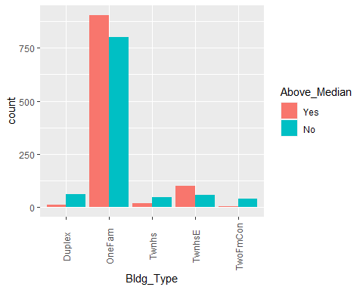

ggplot(Ames, aes(x = Above_Median, y = Neighborhood)) + geom_point()

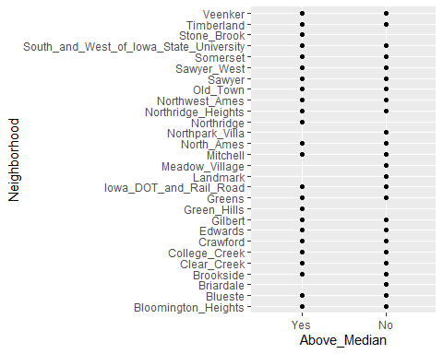

ggplot(Ames, aes(x = Above_Median, y = Kitchen_Qual)) + geom_point() + theme_bw()

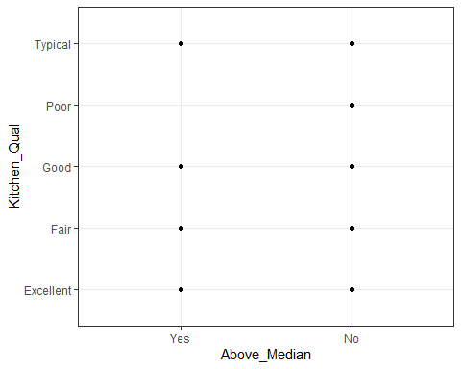

ggplot(Ames, aes(x = Above_Median, y = TotRms_AbvGrd)) + geom_boxplot() + theme_bw()

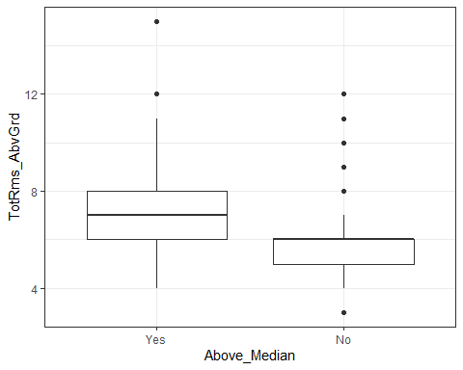

ggplot(Ames, aes(x=Year_Built, fill = Above_Median)) + geom_bar() + theme(axis.text.x = element_text(angle = 90, vjust=0.5))

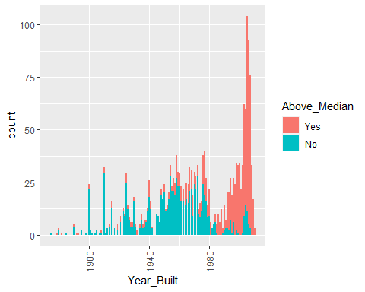

ggplot(Ames, aes(x = Kitchen_Qual, fill = Above_Median)) + geom_bar(position = "fill")

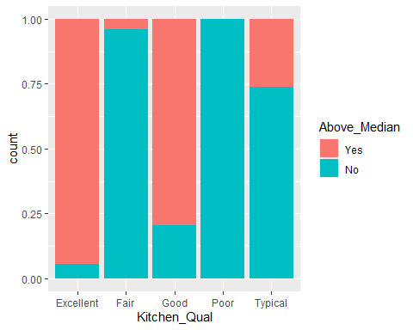

p1 = ggplot(Ames, aes(x = Overall_Cond, fill = Above_Median)) + geom_bar(position = "fill")+theme(axis.text.x = element_text(angle = 90, vjust=0.5))  
p2 = ggplot(Ames, aes(x = Exter_Cond, fill = Above_Median)) + geom_bar(position = "fill")+theme(axis.text.x = element_text(angle = 90, vjust=0.5))  
p3 = ggplot(Ames, aes(x = Bsmt_Cond, fill = Above_Median)) + geom_bar(position = "fill")+theme(axis.text.x = element_text(angle = 90, vjust=0.5))  
p4 = ggplot(Ames, aes(x = Garage_Cond, fill = Above_Median)) + geom_bar(position = "fill")+theme(axis.text.x = element_text(angle = 90, vjust=0.5))  
grid.arrange(p1,p2,p3,p4)

